TERM PAPER REPORT

ON

**ROBOTICS AND ARTIFICIAL INTELLIGENCE**



In partial fulfillment of the requirements of the degree of

**BACHELOR OF TECHNOLOGY**

IN

**COMPUTER SCIENCE AND ENGINEERING**

**BY- SURVEPALLI SREEKRUTI A2305220266**

UNDER THE GUIDELINES OF

**MR. PRAVEEN VASHISHT**

**DEPARTMENT OF COMPUTER SCIENCE AND ENGINEERING**

**AMITY SCHOOL OF ENGINEERING AND TECHNOLOGY**

**AMITY UNIVERSITY, UTTAR PRADESH.**

**DECLARATION**

I, SURVEPALLI SREEKRUTI, student of B-TECH(2-CSE1(X)) hereby declare that the project titled “Robotics and artificial intelligence” which is submitted by me to the department of computer science, amity university, Noida, has not been previously formed for the award of any degree, diploma or other similar recognition. My report is a bonafide and genuine research project under the guidance of Mr Praveen Vashisht.

DATE- 8/07/2021

SURVEPALLI SREEKRUTI

A2305220266

2CSE- 1 X (2020-2024)

**CERTIFICATE**

This is to certify that Ms. Survepalli Sreekruti, student of B.TECH in Computer science and engineering has carried out work in the project of the term paper entitle “ROBOTICS AND ARTIFICIAL INTELLIEGENCE” as a part of first year program of Bachelor of technology in Computer science and engineering from amity university, Noida under my supervision.

MR. PRAVEEN VASHISHT

Department of Computer science and Engineering

ASET, NOIDA

**ACKNOWLEDGEMENT**

The completion of this project would be incomplete without the mention of people whose constant guidance has to be awarded with my success. I would like to thank Prof (Dr) Abhay Bansal, Head od department- CSE, and Amity university for giving me the opportunity to undertake the project. I would like to thank my faculty guide Mr. Praveen Vashisht who is the biggest driving force behind my successful completion of the project. I would like to thank him for solving my queries and also guide me through out.

------------------------------------------

**SURVEPALLI SREEKRUTI**

**ABSTRACT**

Artificial intelligence is a modern science of engineering to make machines intelligent as human beings. We all know that AI has progressed widely over the past decade with giant companies like Google, Microsoft, Tesla, Amazon etc , investing billions of dollars in the field of AI development and research.

Artificial intelligence has also acted the main driver of emerging technologies like big data, robotics and IOT, and it will continue to act as a technological innovator for the foreseeable future.

‘Robot’ can refer to both physical robots and virtual software agents. There is no consensus on which machines qualify as robots but there are some characteristics or functions that are common in all of them-

They accept electronical programming, data processing, move around, operate autonomously in some cases, operate their physical parts itself or by other physical aid, manipulate and sense their environment and exhibit behavior which mimics humans and other animals.

**INTRODUCTION**

The word “**Robot”** was coined by a Czech novelist Karel Capek in a 1920 play titled Rassum ’s Universal Robots (RUR). Robots in Czech is a word for a worker or servant.

The science of robots is termed as **Robotics.**

A robot is a reprogrammable, multifunctional manipulator designed to move tools, parts or specialized devices through variable programmed motions.

Robots basically can be referred to as a computer controlled device that combines the technology of digital computers with the technology of servo-control of articulated chains.

Since history, it was always assumed by all scholars, inventors, engineers or technicians that robots may mimic human behaviour and do tasks in a human like fashion.

And today, robotics is a rapid growing field because of technological advances, designing, researching or building new robots to serve various practical purposes, is taking place quite easily and fast as compared to the past.

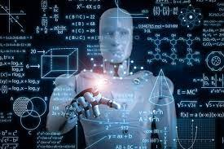

These robots are designed to be used for any purpose but these are used in emergency or sensitive cases like bomb detection, deactivation of bombs etc. Most of the robots in today’s date are inspired by nature so they are termed as Bio-Inspired Robots.

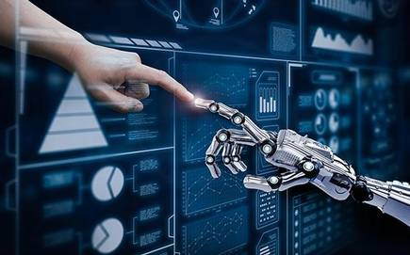

The World Robotics 2020 Industrial Robots report found 2.7 million robots already working across the world. Sales of new robots remain high with 373,000 units shipped globally in 2019, a drop of 12% from the previous year - but still the third highest volume ever recorded.

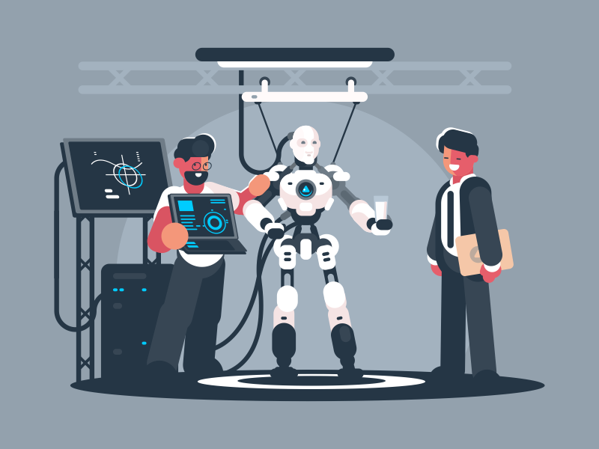 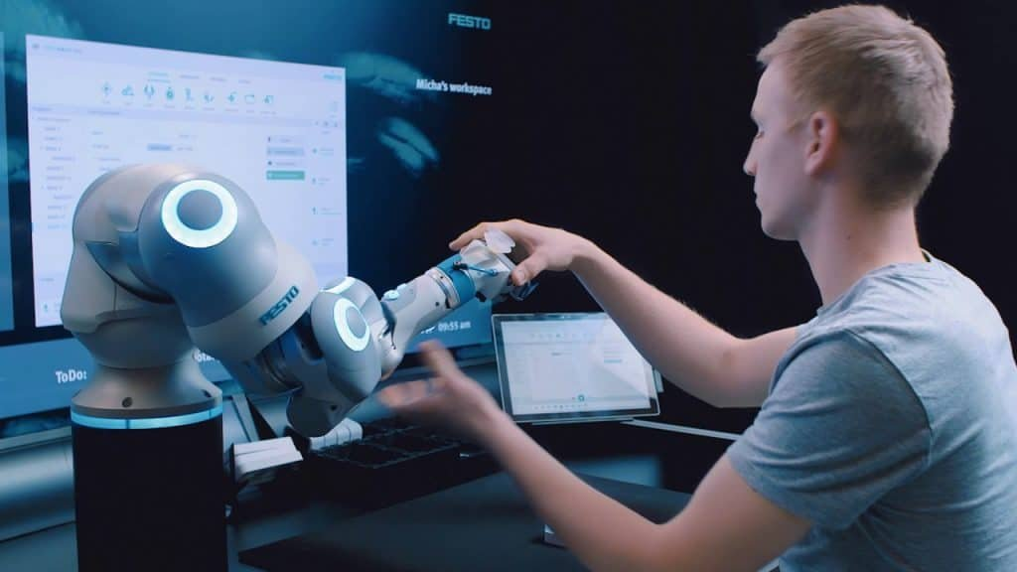

**HISTORY**

People from past till today may perceive robots as dangerous technological ventures, who might someday lead to extinction of human race, either by outsmarting us or by turning us into a complete technology dependent humans.

**1.**Infact the first use of word ‘ROBOTA’ was in 1920’s play RUR (Rossum’s universal robots) by **Karl Kapek**, a Czechoslovakian play writer. Robata actually means ‘worker’ or a peasant.

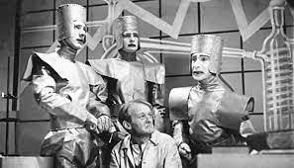

(A picture from the book)

**2**.Its ironical that the word ‘ROBOTICS’ was also coined by a writer. Russian-born American science-fiction writer **Isaac Asimov** first used the word in 1942 in his short story "Runabout." He had generally characterized them as helpful servants and termed ‘robots’ as cleaner and helpful race in his short stories. He even derived ‘Laws of Robotics’ –

1. A robot should not injure a human being by inaction or allow any human being to come to harm them.
2. A robot must follow the orders given to them by human beings except to orders that would contradict with the First Law.
3. A robot must protect its own existence as long as the protection does not contradict with the previous Laws.



(Asimov humanoid robots)

**3.**Finally in 1961, industrial robots were introduced. **Joseph Engleberger** and **George Deveo** built the first industrial robot, the PUMA (Programmable Universal Manipulator Arm). They were inspired by human arm.

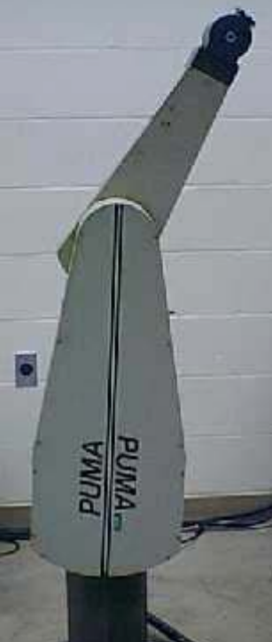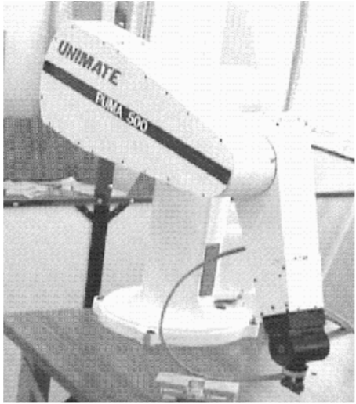

**4**.In 1958 at the Stanford Research Institute, **Charles Rosen** led a research team in developing a robot called "Shakey**.**"  It was more advanced than the original unimate, which was designed for specialized, industrial applications. It could wheel around the room, observe the scene with his television "eyes," move across unfamiliar surroundings, and to a certain degree, respond to his environment.

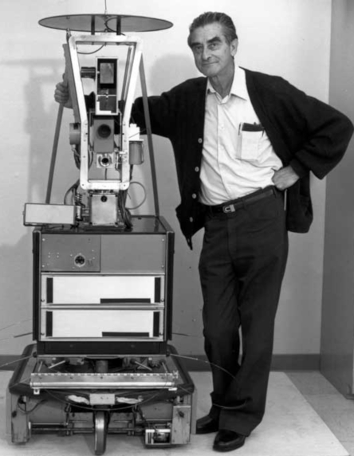

(‘ SHAKEY ’)

5. The development of humanoid robots was advanced considerably by Japanese scientists in the 1970s. Waseda university initiated the **WABOT** project in 1967, and in 1972 completed the WABOT-1, the world's first full-scale humanoid intelligent robot.

6. In April 2001, the **Canadarm 2** was launched into orbit and attached to the International space station.

**7. Robonaut 2,** the first humanoid robot was sent to space in 2011. On 25 October 2017 a robot called [Sophia](https://en.wikipedia.org/wiki/Sophia_(robot)) was made in Saudi Arabia.

**CHARACTERSTICS OF ROBOTS**

“Carrying out actions automatically and Programmable by a computer”- These are the key elements in robotics.

Robots all consist of some sort of mechanical construction. The mechanical aspect of a robot helps it complete tasks in the environment for which it’s designed.

* **Appearance:** Robots have a physical body. They are also held by their structure of the body just like we do, and move with their mechanical parts.
* **Brain:**  Brain in robots is called ON-BOARD CONTROLLING UNIT. With this they receive the information and they command the actions as output.
* **Sensors:**  The use of sensors in robots is to obtain info from the outside and send it to Brain. Sensors are what enable a robot to carry out complex tasks. This is the characteristic that outshines robots from other program based machinery.
* **Actuators:** For robots to move a tool is installed in them and they are called Actuators. Their brain tells these actuators when and how to respond or move.
* **Program:** Robots are like living + non living species who works or responds to only those instructions which are installed in them as a program. Eg- when to move, produce sounds etc. These programs tell the robot how to use sensors and data to make decisions.
* **Behaviour:** Robots behaviour is decided by the program installed in them.
* **Intelligence:**. Innovations in the realms of computation and data mining enable the development of artificially intelligent systems that reflect human intellectual capability. A robot known as, Kismet works very similarly to the human nervous system, which consists of both voluntary and involuntary functionality.
* **POWER:** Robots require an energy source. Generators, batteries and fuel cells give power that is locally stored but also temporary, while tethering to a power source naturally limits the device’s freedom and range of functions.

Modern robots have already overcome many of the hardest challenges until just a few years ago. The robot race is running at an amazingly fast pace, and we can only wonder what machines could achieve in the upcoming future.

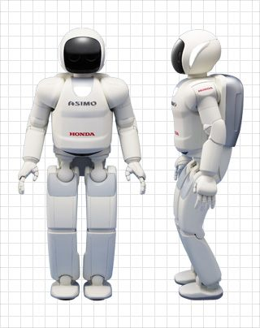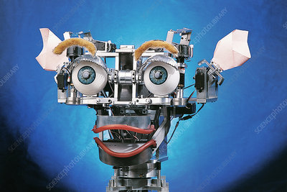

**(‘HONDA HUMANOID’) (‘KISMET’)**

**TYPES OF ROBOTS**

It’s not easy to define what robots are, and it’s not easy to categorize them either. Each robot has its own unique features, and as a whole robots vary hugely in size, shape, and capabilities. Lets see some of the types.

* **AEROSPACE:** It includes all sorts of flying robots—the Smart Bird robotic seagull and the Raven surveillance drone.

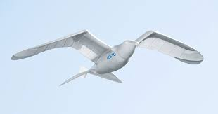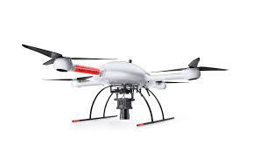

* **CONSUMER:** Consumer robots and robotic devices are made for the use of public. Many of them are designed for everyday chores such as household robots, vacuum robots, lawn mowing robots, pool cleaning robots, etc. A robot dog Aibo, Roomba Vaccum etc, are examples.

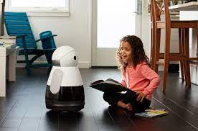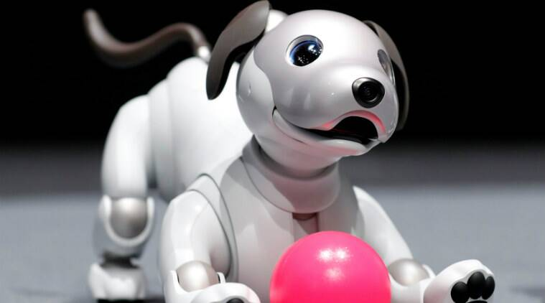

* **DISASTER RESPONSE:** These robots perform dangerous jobs like searching for survivors in the aftermath of an emergency. They may assist rescue efforts by searching, mapping, removing rubble, delivering supplies, providing medical treatment or evacuating casualties. Eg- Centauro robot.

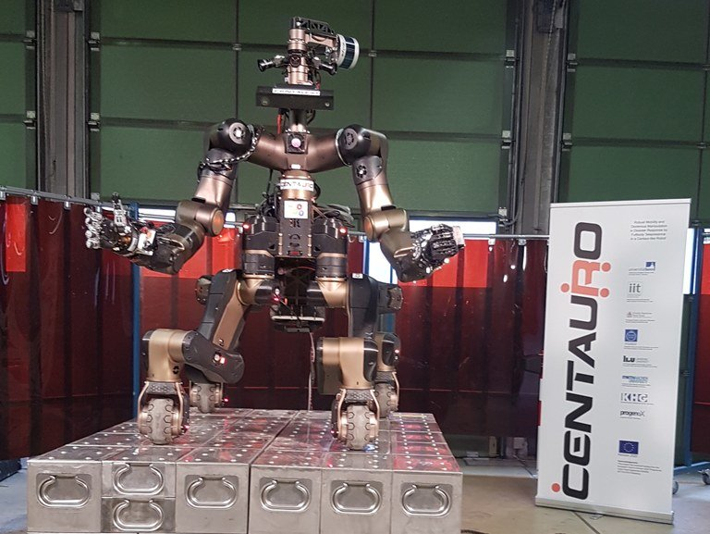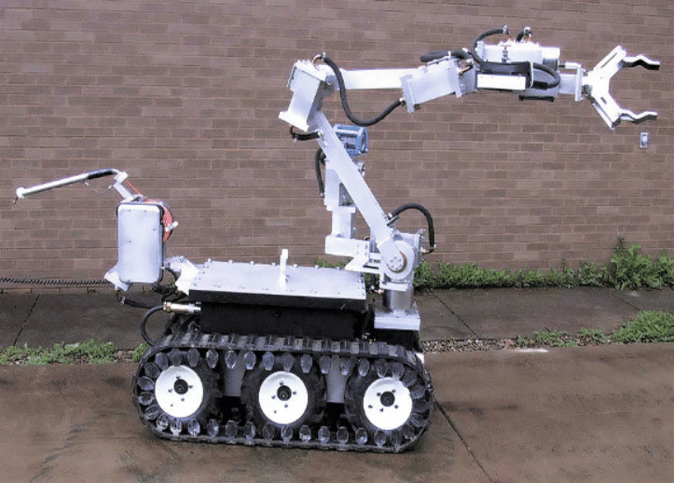

* **EDUCATION:** This broad category is aimed at the next generation of roboticists, for use at home or in classrooms. It includes hands-on programmable sets from Lego, 3D printers with lesson plans, and even teacher robots like EMYS. Eg-mbots, robo wunderkinds etc.

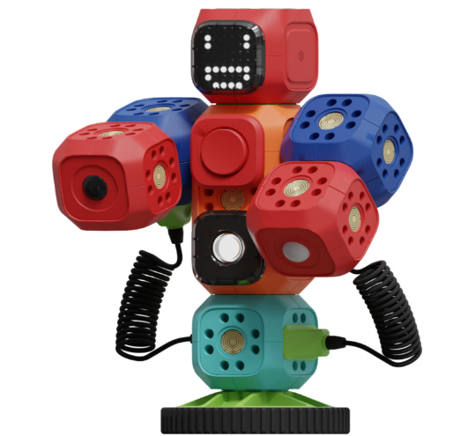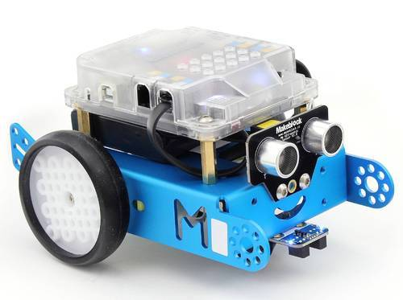

* **ENTERTAINMENT:** These robots are designed to evoke an emotional response and make us laugh or feel surprise or in awe. Eg- Honda Asimov, Dynamics robot dog Spot, Pepper robot etc.

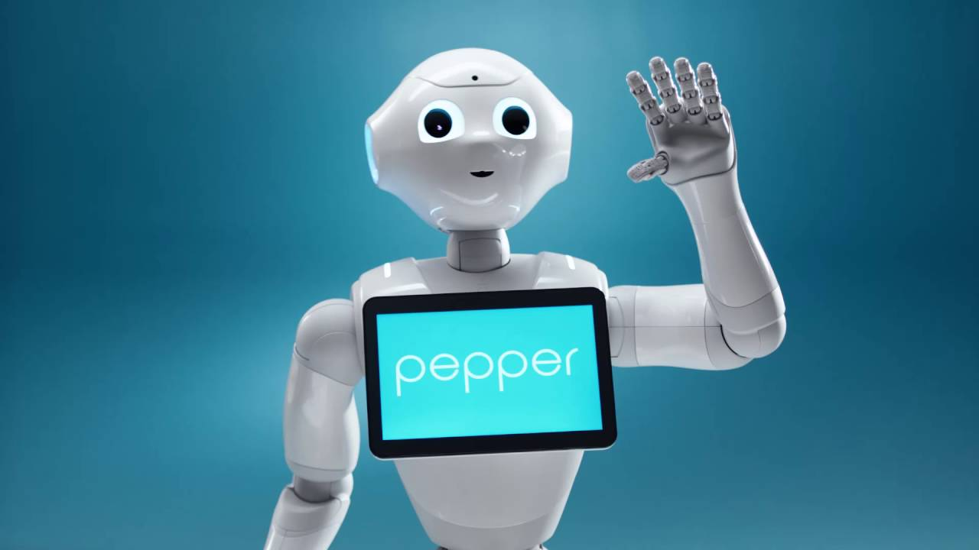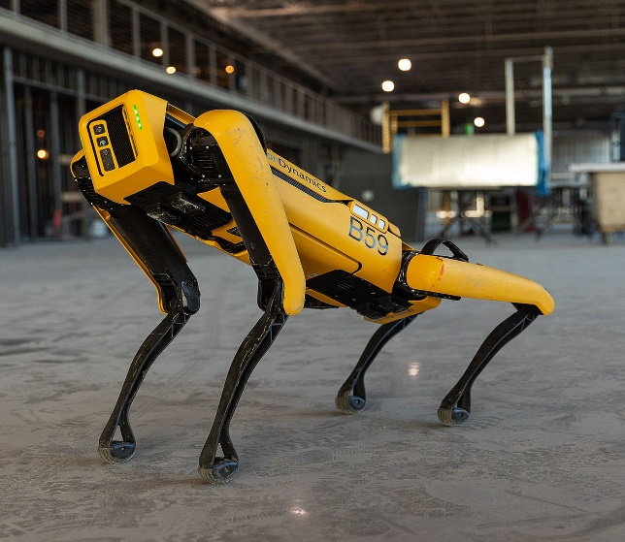

**HUMANOIDS:** A humanoid robot is a robot with its body shape built to resemble the humans. Humanoids were initially only built for scientific purposes but through years they are also used to perform tasks like personal assistance etc. Eg- Sophia, robot Shalu etc.

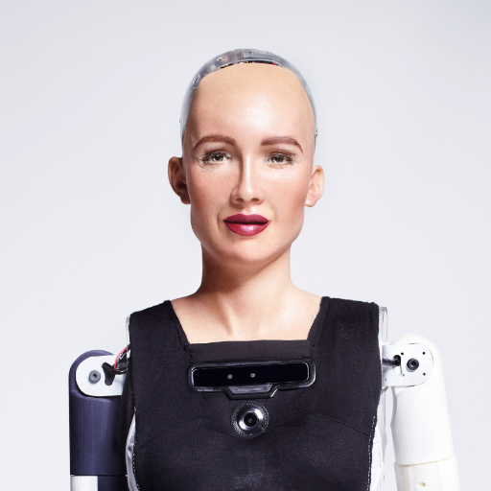

**(‘SOPHIA’) (‘ROBOT SHALU’)**

**INDUSTRIAL:** An industrial robot is a robot system used for manufacturing. Industrial robots are automated, programmable and capable of movement on three or more axes. Eg- Articulated robots, Cartesian robots, SCARA etc

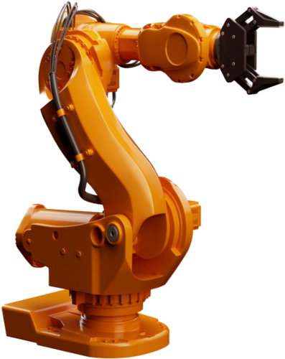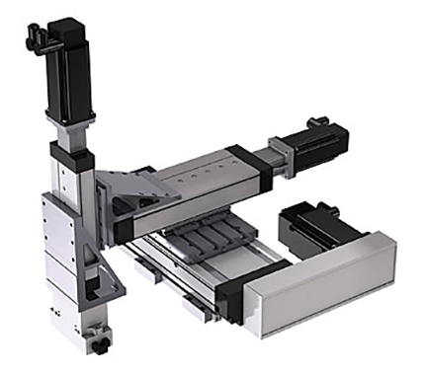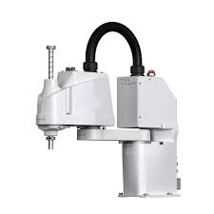

**(‘ARTICULATED’)** **(‘CARTESIAN’)** **(‘SCARA’)**

Let’s see some industrial robots-

**Articulated robots:** An articulated robot is a robot with rotatory joints. They can be dead simple as a two axis structure or complex with ten or more axes and are typically powered by servo motors.

**Cartesian robots:** A Cartesian robot is an robot whose three principal axis of control are linear and are at right angles to each other.

**Scara robots:** The acronym stands for Selective Compliance Assembly Robot Armor Selective Compliance Articulated Robot Arm. By virtue of the SCARA's parallel-axis joint layout, the arm is totally rigid in the Z direction but tilted in X-Y direction. This characteristic allows the arm to extend in confined areas and then retract or "fold up" out of the way.

**Delta robots:** Delta robots consists of parallel joint linkages connected with a common base. These robots are generally used for fast pick-and-place or product transfer applications.

**Polar robots:** Polar robots have a twisting joint connecting the arms with the base and a combination of two rotary joints and one linear joint connecting the links. These robots have a centrally pivoting shaft and an extendable rotating arm.

**Cylindrical robots:** Cylindrical robots have at least one rotary joint at the base and at least one prismatic joint connecting the links. These robots have a cylindrical workspace with a pivoting shaft and an extendable arm which moves vertically and by sliding.

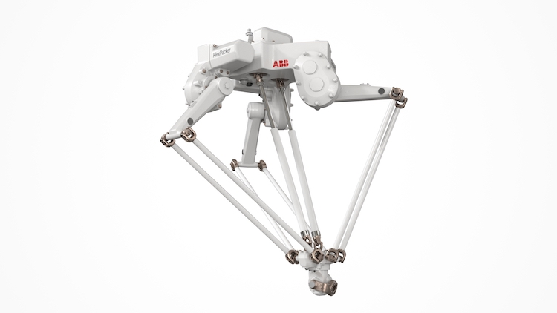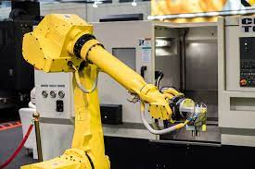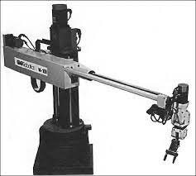

**(‘DELTA’**) **(‘POLAR’)** **(‘CYINDRICAL’)**

* **MEDICAL:** Medical and health-care robots include systems such as the da Vinci surgical robot and bionic prostheses, as well as robotic exoskeletons. Eg- Watson.

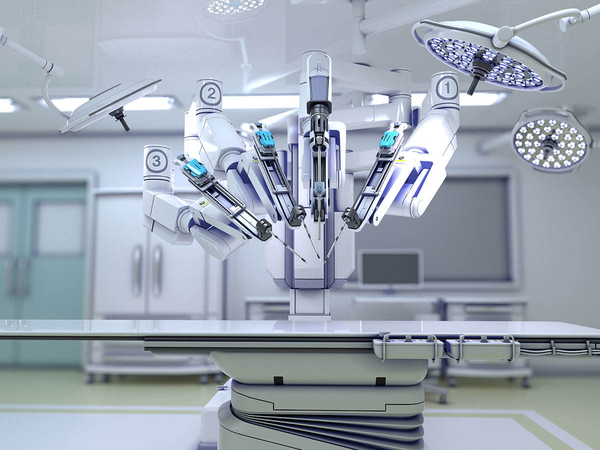

* **MILITARY AND SECURITY:** Military robots include ground systems like PackBot, used to scout for improvised explosive devices, and BigDog, designed to assist troops in carrying heavy gear. Security robots include autonomous mobile systems such as Cobalt.

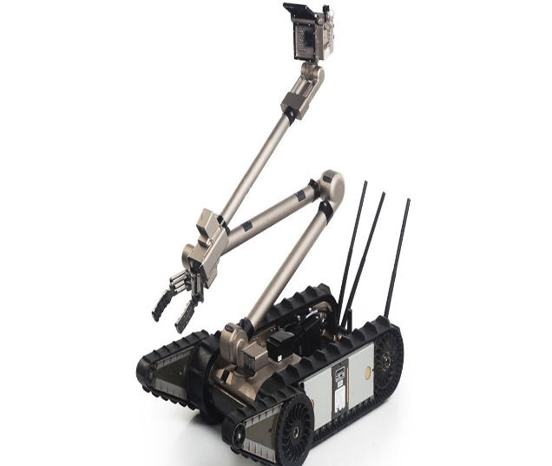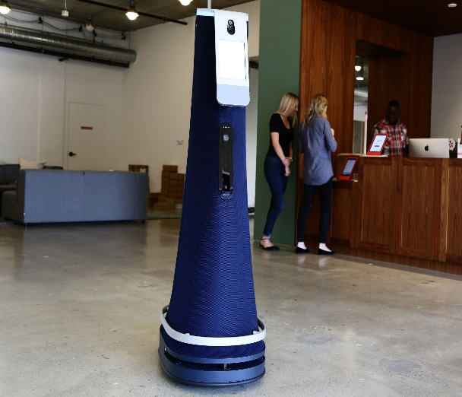

* **TELEPRESENCE:** Telepresence robots allow you to be present at a place without actually going there. You log on to a robot avatar via internet and drive it around and talking to people.

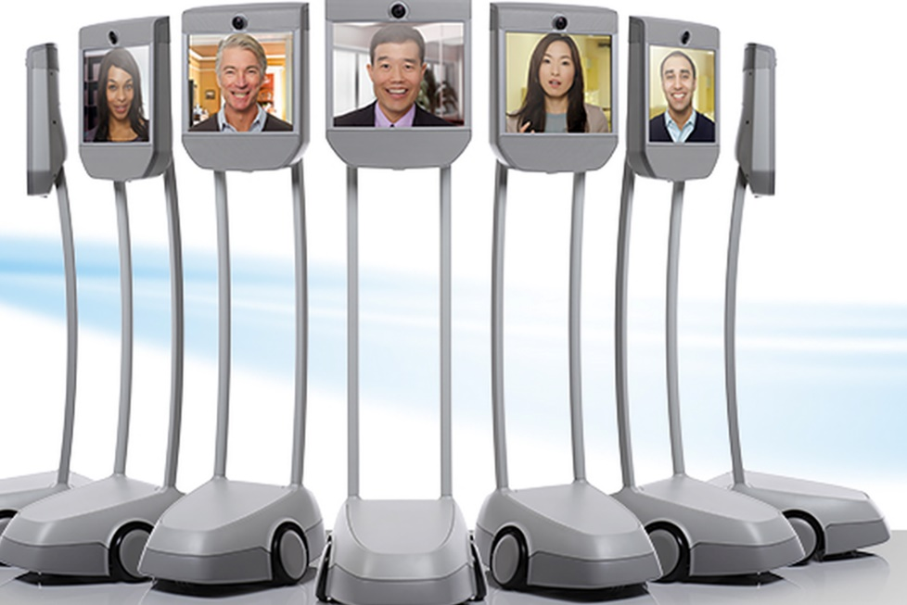

* **UNDERWATER:** The favourite place for these robots is in the water. They consist of deep-sea submersibles like Aquanaut, diving humanoids like Ocean One, and bio-inspired systems like the ACM-R5H snakebot.

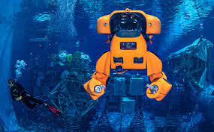

**ADVANTAGES AND DISADVANTAGES OF ROBOTICS**

**ADVANTAGES:**

**1.**They increase production- They’re designed for a job, and they don’t stop doing it unless they breakdown or you turn them off.

**2.**They are more accurate than humans

**3.**They make fewer mistakes- Robots don’t make mistakes! Humans do. We get flustered, crumble under pressure, forget stuff, or just get lazy. The same cannot be said for robots.

**4**.They are more reliable than humans

**5.**They can work 24/7

**6.**They save time

**7.**They are versatile- You can design a robot for almost any task.

**8.**They are automatic- They can perform various task even without human intervention.

**9.**They can be used for any work- Robots are used in so many different factories to produce or construct items like car parts, planes, electronical equipments and many more. They can also be used in mining factories or even be sent to Earth’s Nadris.

**DISADVANTAGES-**

**1.**They need constant power- Robots need oodles of electricity to run.

**2.**They are restricted to their programming- Robots can’t think for themselves. They rely on clever humans to program them for specific tasks.

**3.** They are expensive to install and run- Robots aren’t cheap- especially when they’re high-tech, top of the line and needed for a specific task.

**4.** They pose potential physical danger from malfunctions- The last thing you want is for a malfunction to cause the robot to do something dangerous.

**5.** They might make humans overrelaint- As they become more widely-available, used, and accepted in society, we’ll become ever more reliant on them, where humans become overweight and entirely dependent on robots for support.

**6.** They might also create employment problems- There are so many people working in factories all over the world, they may be out of their jobs as robots can replace them because the are faster and make less mistakes.

**7.** They might take over the world- Computers are getting more intelligent by the day. Sooner or later they’ll develop a level on sentience that enables them to make decisions for themselves.

We all can guarantee that they’ll be a major part of society in future too. Heck, one day they might even rise up and overthrow us. Until then, though, we can enjoy the many advantages of robots on offer, while keeping a close eye on the

**ROBOTICS AND ARTIFICIAL INTELLIGENCE**

Robotics is a sub branch of AI, which is composed of Electrical and Mechanical Engineering along with Computer Sciences for construction, designing and application of robots.

The first thing to clarify is that robotics and artificial intelligence are not the same things at all. In fact, the two fields are almost entirely separate. Lets understand-

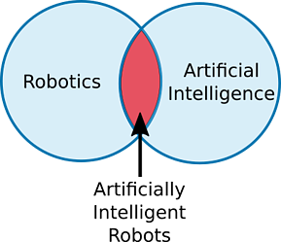

What is robotics-

Robotics is a branch of technology that deals with physical robots. Robots are program based machines that are usually able to carry out a series of actions autonomously, or semi-autonomously. Eg- basic combat(nonintelligent robot) etc.

What is artificial intelligence-

Artificial intelligence (AI) is a branch of computer science. It involves completing tasks by developing computer programs, that would otherwise require human intelligence. AI algorithms can tackle learning, perception, problem-solving, language-understanding and/or logical reasoning. Eg- alpha go etc.

ARTIFICIALLY INTELLIGENT ROBOTS-

Artificially intelligent robots are the bridge between robotics and AI. These are robots that are controlled by AI programs. Most robots are not artificially intelligent. AI algorithms are necessary when you want to allow the robot to perform more complex tasks.

Eg- A self-driving car might use a combination of AI algorithms to detect and avoid potential hazards on the road.  A drone might use autonomous navigation to return home when it is about to run out of battery.

As you can see, artificial intelligence and robotics are really two separate things. Robotics involves building robots physical whereas AI involves programming intelligence.

|  |  |
| --- | --- |
| **AI Programs** | **Robots** |
| They usually operate in computer-based worlds. | They operate in real and physical physical world |
| AI is the bridge between human intelligence and machine learning | Robotics is a sub branch of AI that uses it to improve it’s functions. |
| Its human intelligence that compliments our mind to enhance its ability for performing taks and self improvisation. | They are autonomous or semiautonomous that use comp systems for their control or information processing. |

Robots are autonomous or semi-autonomous machines meaning that they can act independently of external commands. Artificial intelligence is software that learns and self-improves.  
In some cases, robots make use of artificial intelligence to improve their autonomous functions by learning. However it is also common for robots to be designed with no capability to self-improve.

This is the reason robotics have a wide future. We can use AI and machine learning together with robotics to make advanced robots which would be more handy, easy and multifunctional.

**WORLD OF ROBOTICS**

**Chinese** is the leader in the robotic sales worldwide with a share of about 40% (as of 2020) according to the International Federation of Robots.

**South Korea, Japan** and **U.S.** are in second, third and fourth placesrespectively.

**Indian IT and the Indian generic drugs industry** are the two areas where Indian companies have taken a march ahead of their Chinese counterparts.

**Grey Orange**, a company founded by a bunch of Indian techies in 2011 is India’s biggest robotic technology company. They have revolutionized supply chain automation.

Other Indian start up companies in robotics are ASIMOV Robotics, I2U2 Robot and Sastra Robotics India etc.

**Robotics in India-**

A study released by industry association **ASSOCHAM** states that ‘Robotics are a settled necessity for taking Indian industry globally competitive and the making country attractive for outside entrepreneurs for the “Make in India” drive.’

***IMPEDIMENTS-***

* Lack of hardware ecosystem- Results in imports of most of the components overcoming challenges in dual-use certifications, high import duties, customs amongst other permission driven environments.
* Financial incentives
* Critical human resources- Lack of quality human resources with necessary skills and expertise to work with advanced manufacturing technologies negatively impacts the ability to undertake cutting edge R&D in India.
* **Mindset shift required-**The industry faces political hurdles.

***ROBOT COMPANIES IN INDIA-***

* Thiruvananthapuram-based start up Genrobotics joined hands with the Kerala government to deploy a spider-shaped robot named **“Bandicoot”** to clean sewers and manholes in the city.
* Bangalore-based SME Suparna Plastics Ltd. which makes plastic ball valves is using **SCARA** robots for the high speed and accuracy it brings to the table.
* Ahmedabad-based Apex hospital used **Corpath technology of US-based Corindus Vascular Robotics** to remotely control a robot to perform a telerobotic heart surgery on a patient.
* **Manav,** India’s first 3D-printed humanoid robot.
* **Mitra**, the first indigenously built humanoid robotis capable of interacting with humans smartly.
* **DRDO’s Daksh-**This made-in-India robot is primarily designed to detect and recover Improvised Explosive Devices (IEDs).

**BEST ROBOT COMPANIES IN THE WORLD-**

## Midea Group- Today, Midea Group deploys over 800 robots in production. Headquarters: Foshan, China.

## Denso Corp- Denso builds industrial robots and programmable logic controllers used in manufacturing factory automation. Headquarters: Kariya, Japan.

## Sony- Sony designed and developed a robotic pet called AIBO. This dog bot has the ability to communicate with its human owner as a normal pet would. Headquarters: Tokyo, Japan.

## Siemens AG- Siemens AG is a global major player focusing on the areas of power generation, smart building infrastructure and distributed energy systems. Headquarters: Munich, Germany.

## Honda-Honda Robotics developed the “most advanced humanoid robot”, ASIMO. Headquarters: Tokyo, Japan.

## 

## OBSERVATION

Robots are found everywhere: in factories, homes and hospitals, and even in outerspace. Much research and development is being invested in developing robots that

interact with humans directly.

Robots have wide variety of use cases that make them the ideal technology for the future. Soon, we will see robots almost everywhere. We'll see them in our hospitals, in our hotels and even on our roads.

Caterpillar company plans which is aiming to develop remote-controlled machines and are expecting to develop heavy robots by end of 2021.

Robots are increasingly been used more than humans in manufacturing while in auto-industry there are more than half of the labours are “Robots”.

Many of the robots are also used as Military Robots.

Today, we have experts in AI, ethics and morals to help provide sensible guidelines for the creation and use of robots. Some researchers also hope to empower robots and give them the ability to judge ethical and moral consequences for themselves.

## Artificial intelligence, digitization, and automation have already created a disruption in long-standing industries and societies and will continue to do so.

## Disruptive innovation in this Third Industrial Revolution- with the ability of computers to reduce communication time, complete tasks and transform an ever-evolving number of data input into systems of pure information that can be reorganized into vast interactive networks that function akin to complex ecosystems-will be equally historic and important.

## 

## REFERENCES-

## en.wikipedia.org

## 1 library.co

## [www.tutorialspoint.com](http://www.tutorialspoint.com)

## pdfcoffee.com

## [www.ijsrd.com](http://www.ijsrd.com)

## moam.info